**Analysis Conclusions**

The final KNIME workflow is shown below:

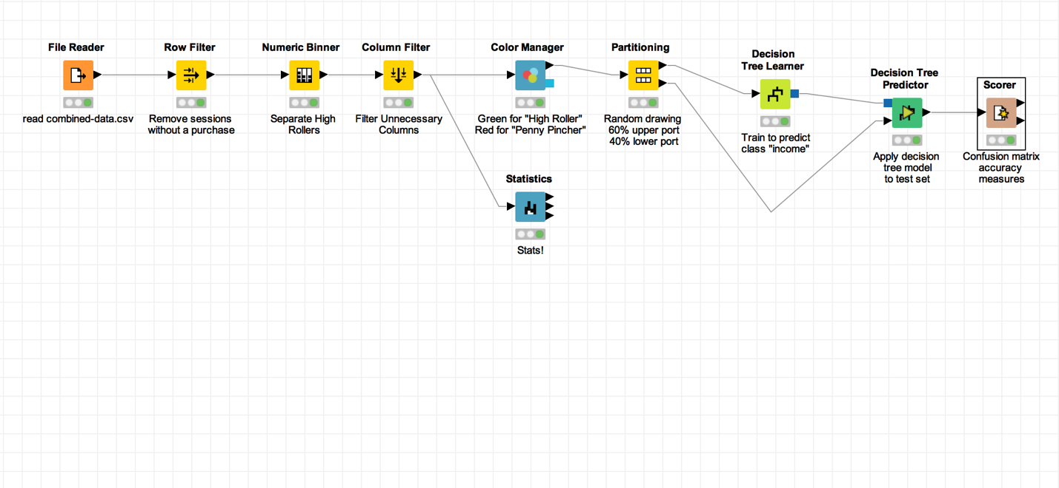

What makes a HighRoller vs. a PennyPincher?

**The OS used. Users who are HighRoller use iOS. PennyPincher use Android, Mac, Win, Linux.**

|  |
| --- |
| **Specific Recommendations to Increase Revenue** |
| 1. Target promotions to iOS users. |
| 2. Target future product develop towards iOS. |